new jars (ying  or chui ) and cover the mouths with thin fresh rawhide. These

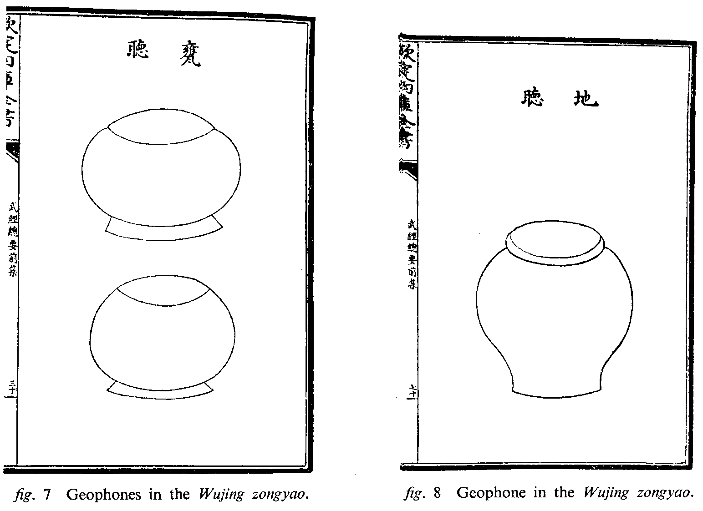
geophones (see figures 7-8) were taken down into the bottom of the wells where those with acute hearing were to hold the jars to the earth and listen for the sounds of the enemy miners. By this method they could locate exactly the direction and the depth of the approaching tunnels. Once the depths and directions had been ascertained, the defenders were to dig their own countermines as quickly as possible to intercept the enemy.

Fifty miners, of both sexes, were to excavate the defending mines and the earth was to be pulled to the surface in baskets by some kind of system of ropes and pulleys. Unfortunately, the technique involved is unclear, although it is specified that 40 baskets were to be provided for each mine .⁵⁴ The countermines themselves were to be started from the wells sunk close to the walls and were to descend at an angle of 30 30'. The top of the well was to be protected by a stone wall 7 feet high and crowned by a parapet: the only means of reaching the bottom was to be a rope ladder. At the bottom
