**Images**

The two most common file formats are jpegs and gifs. The .tiff and .png formats are becoming more common – see <http://en.wikipedia.org/wiki/Image_file_formats> -but jpeg/jpg and gif dominate.

Photos are stored with a .jpg or .jpeg extension; flat drawings have a .gif extension. For example

is a jpeg and 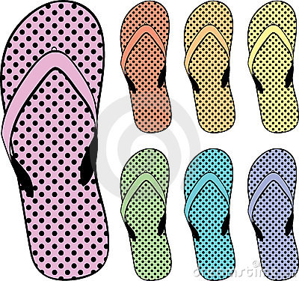 is a gif.

**Ref:** [**http://htmlhelp.com/design/imageuse.htm**](http://htmlhelp.com/design/imageuse.htm) **a short introduction to image files**

**Read Lathrop The Way Computer Graphics Works p. 1-18**

**Read Wyman Designing Web Graphics on dithering and anti-aliasing (on reserve in   
 the Library)** or both <http://www.walthowe.com/pubweb/gg3.html> and   
 <http://en.wikipedia.org/wiki/Dither#Digital_photography_and_image_processing>   
 The practical article at <http://www.practicalecommerce.com/articles/1821-Image-Formats-What-s-the-Difference-Between-JPG-GIF-PNG-> is also helpful. There are still some Windows XP computers out there, which do not support PNG. Some older versions of Firefox (2012) also have PNG-related bugs. SVG is not supported on older mobile devices, but becoming common.

If you have a web site with many photographic images, loading those images may slow down your page. There are several approaches to this problem:

* If you have many images on the same page (e.g. a store) you might use smaller   
  images (really small ones are called thumbnails) and have the user click to either see a larger pop-up version or go to a page about the product.   
  This is very common. For example, any search on llbean.com or chicos.com will yield a page which uses both these techniques.
* You can pre-load some images. We will do this when we learn how to do roll-overs.
* You can use a more limited set of colors (fewer bits to describe each color). This is   
  called compression and the Wyman book has a fine discussion of it. An introduction is at <http://en.wikipedia.org/wiki/Image_compression>
* You can load the images in pieces.
* You can switch from photographic images to fairly flat drawings (Photos are stored with a .jpg or .jpeg extension; flat drawings have a .gif extension.) For example, Southwest Airlines <http://www.southwest.com/> uses only a very few photos and many gifs on their homepage.  
    
  There are now many free gifs available with quite a bit of detail.