Using the Console to Inspect Your HTML Page and its DOM
Both Chrome and Firefox have tools to help you debug your web pages.
You can access these tools by first loading your page in your browser and then pressing either ctl-Shift-I (cmd-Shift-I) or the F12 button.
Let's use http://web.simmons.edu/~menzin/CS321/Unit_1_Basic_HTML5_and_CSS/Chapter_0_Basic_HTML/ as the page to examine.
In Chrome (I have docked my tools at the right) my page looks like:

1
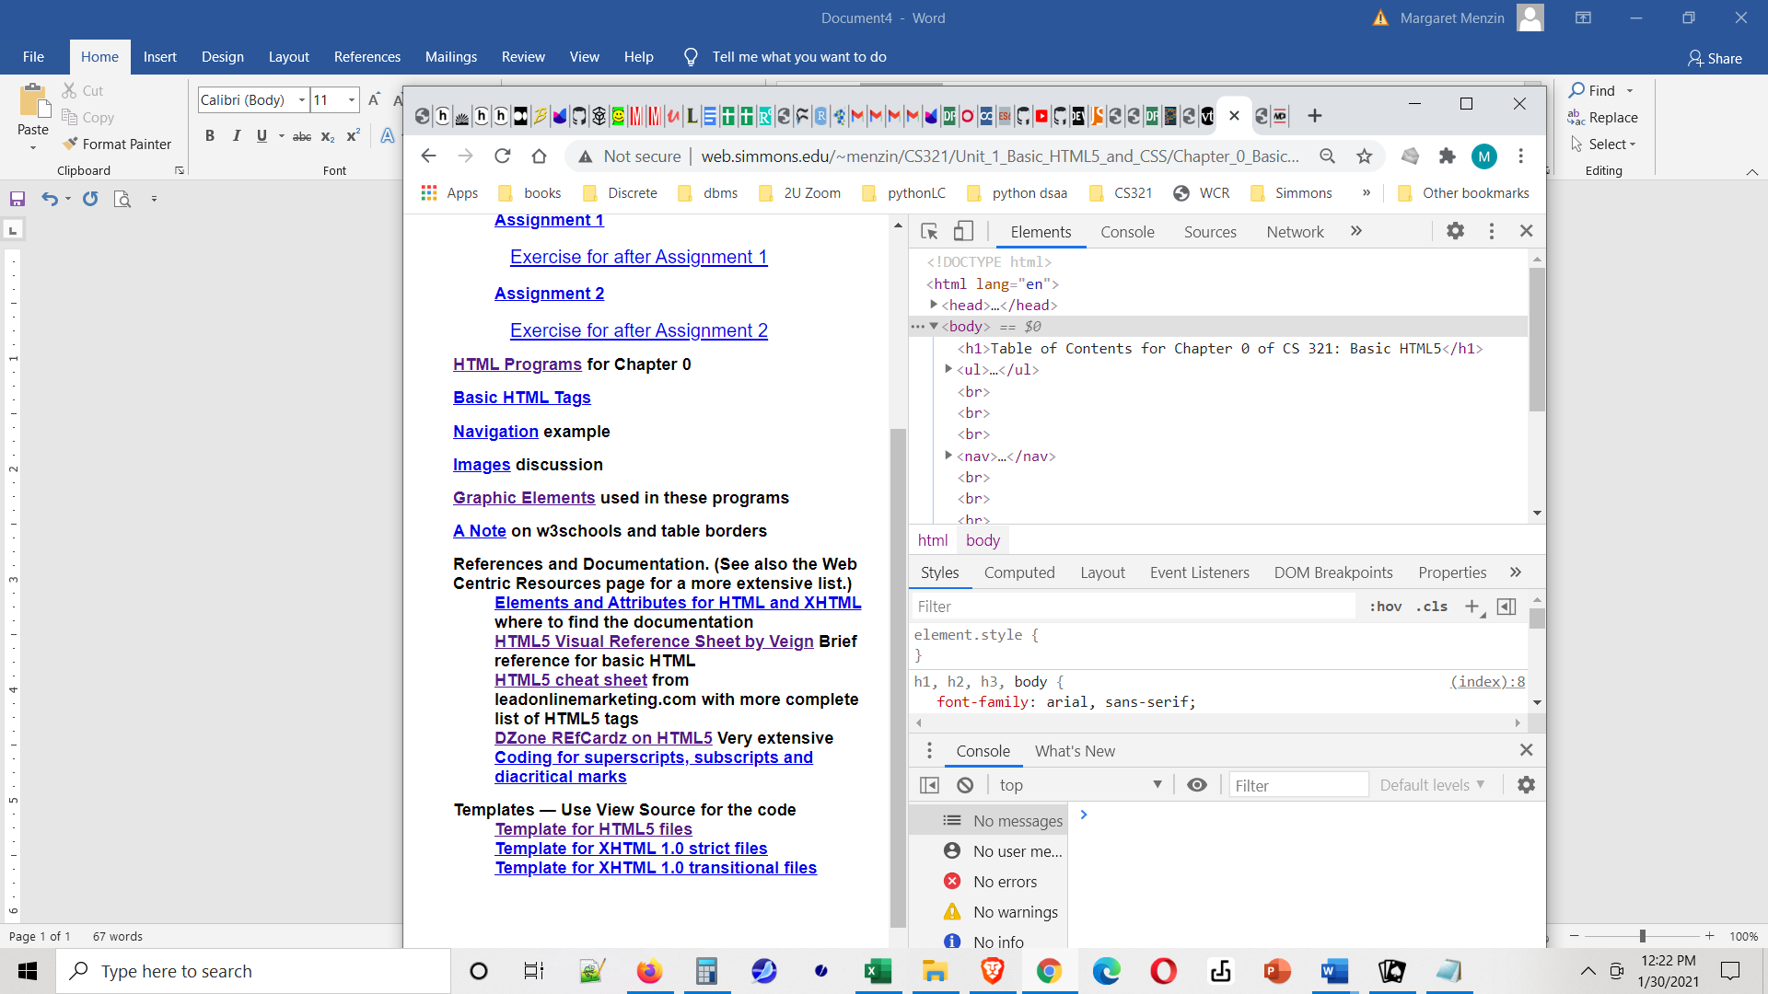
2

Make sure that the top right frame has selected Elements (Arrow 1)
Click on the various tags in that pane to open and close them and inspect your page.
If you open them enough to get to a <p> & put your cursor over it them it should be highlighted on the left (the actual web page) – see next screenshot.
Move down to the Styles in the panel below the Elements panel (Arrow 2)
We haven't applied any styling yet, so you will see the default styling for each element.
Let's try the same thin on the page at http://web.simmons.edu/~menzin/CS321/Unit_1_Basic_HTML5_and_CSS/Chapter_0_Basic_HTML/Navigation/
Now, putting my cursor over the second paragraph I see
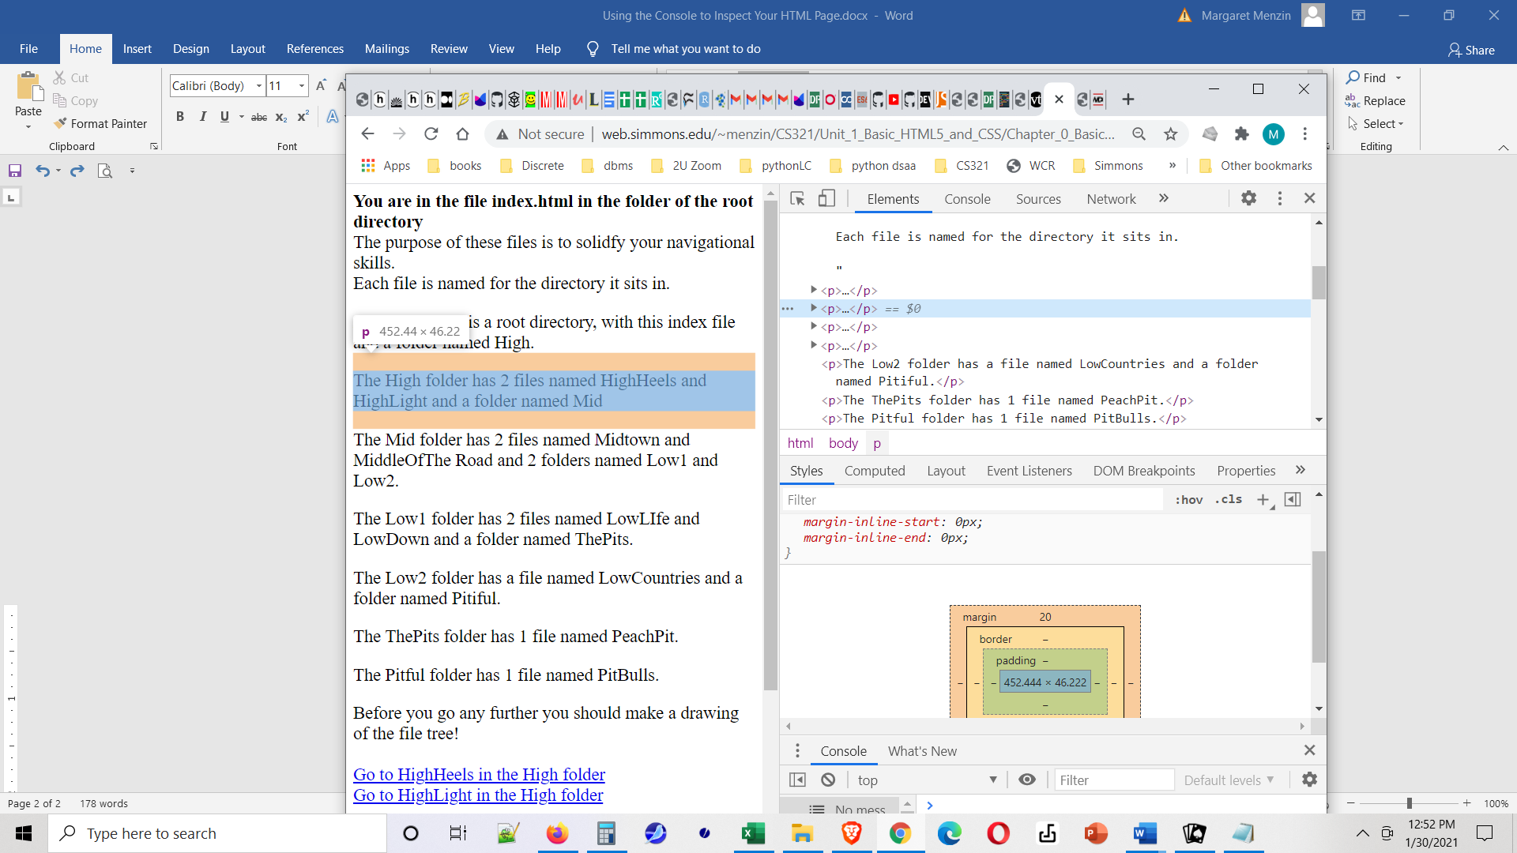
Notice how the highlighting shows the correspondences and also the lower panel now shows the box model for this paragraph (which is coming in Chapter 1.)

Next let's look at this last page in Firefox. (I have docked my tools at the bottom of the page, but you can move it easily.).
What Chrome calls "Elements" is "Inspector" in Firefox, and the { } Style Editor will actually allow me to add a stylesheet. BTW the … at the top of the menu bar allows you to also show the console (useful when we et to JavaScript) and dock these tools in different places.
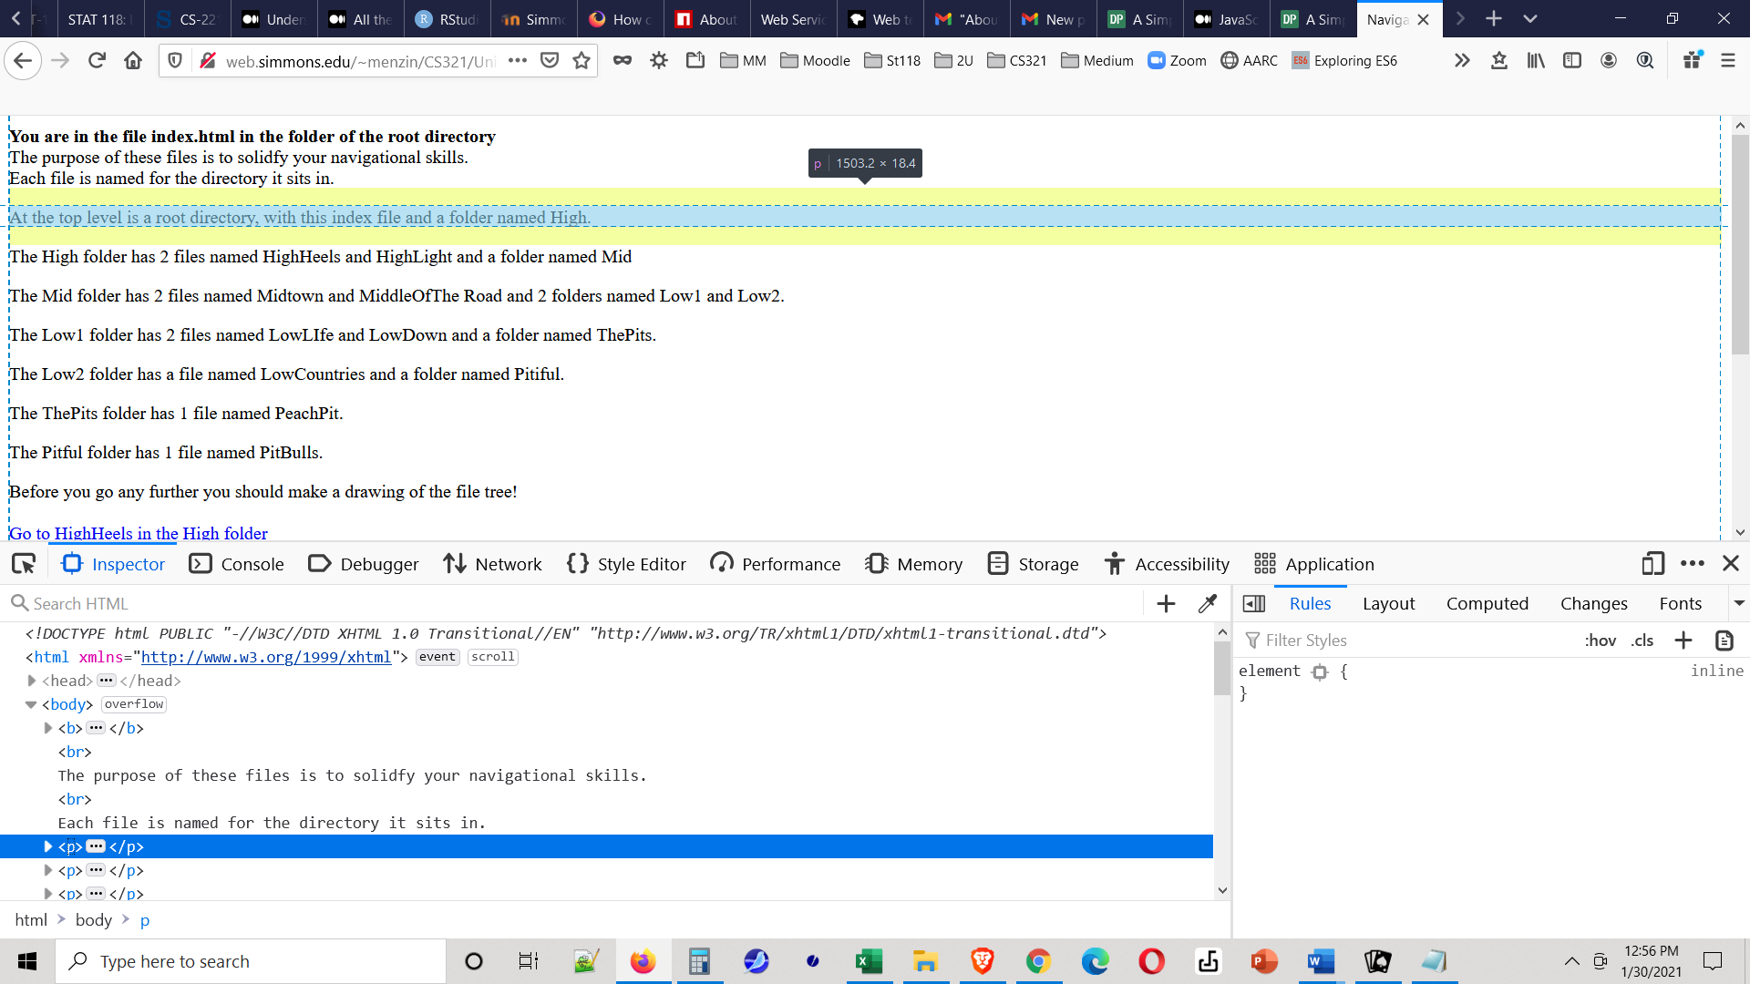

Finally, and very importantly notice that these tools give a graphical representation of the structure of your page. This tree is called the DOM or Document Object Model, and will be very important a little later in the course.

