Code for simple examples
Some modules whose exported objects/methods we will need to use:
- http module https://nodejs.org/api/http.html
  - http.createServer(function(req, res) { }) and properties of req, res
    - req.method
    - req.on() an event handler
    - res.writeHead()
    - res.end()
  - listen(portnumber) or listen(portnumber, url)
  - You will often see code like:
const PORT = process.env.PORT || 3000;
This allows you to use the environment's port if it is specified, and then, obviously, you would use this as the parameter for portnumber in listen().
- url module
  - url.parse() method – sadly this is now "legacy & you should be using the search and searchParams methods https://nodejs.org/api/url.html#url_class_url
- querystringmodule – this is also now legacy and has been replaced by URLSearchParams https://nodejs.org/docs/latest/api/url.html#url_class_urlsearchparams
- fs module
  - readFileSync()
  - The replace() method used here is JavaScript and not from Node
- Also for JSON objects the stringify and parse methods.
  - JSON.stringify(some_JavaScript_object) is a JSON string
  - JSON.stringify(some_JSON_String) is a JavaScript object
NOTE: There is a global JSON object in JavaScript, so the two lines above are using the methods which come with that object and are not using Node.

First some comments about paths, query strings etc.
For a GET the key-value pairs have been appended to the request URL --- so we will extract them from there.
For a POST it is in the body --- and typically it would be the data returned when there was a data event.
We would then store it in a variable (customarily called body), use querystring.parse(body). And store that in a variable myDataFromForm. Now we can access the values which the form posted to us as myDataFromForm.name, etc.
You can find examples of this kind of code at https://stackoverflow.com/questions/4295782/how-to-process-post-data-in-node-js (scroll past the express examples) and https://codezup.com/handle-process-http-post-request-data-node-js-tutorial/ (about 2/3 of the way down) (let's look at this now – I sent you a copy of this tutorial please notice that the body variable holds an object with the data which was POSTed by the form. Of course, in your callback function you may make use of this data! ) and https://www.edureka.co/community/74955/how-to-process-post-data-in-node-js As mentioned above, instead of using the querystring module we need to use URLSearchParams.
Alternatively, you can put all the data together and then split it on the = sign. This is shown in https://www.tutorialspoint.com/parsing-request-body-in-node Or possibly use JSON.parse on that data. See https://flaviocopes.com/nodejs-parse-json/ Another example of readin data in chunks is at https://itnext.io/how-to-handle-the-post-request-body-in-node-js-without-using-a-framework-cd2038b93190

From the Brad Dayley book on Node etc 2nd edition https://learning.oreilly.com/library/view/nodejs-mongodb-and/9780134655642/ch07.xhtml
Remember that in Node.js we always have __dirname and __filename
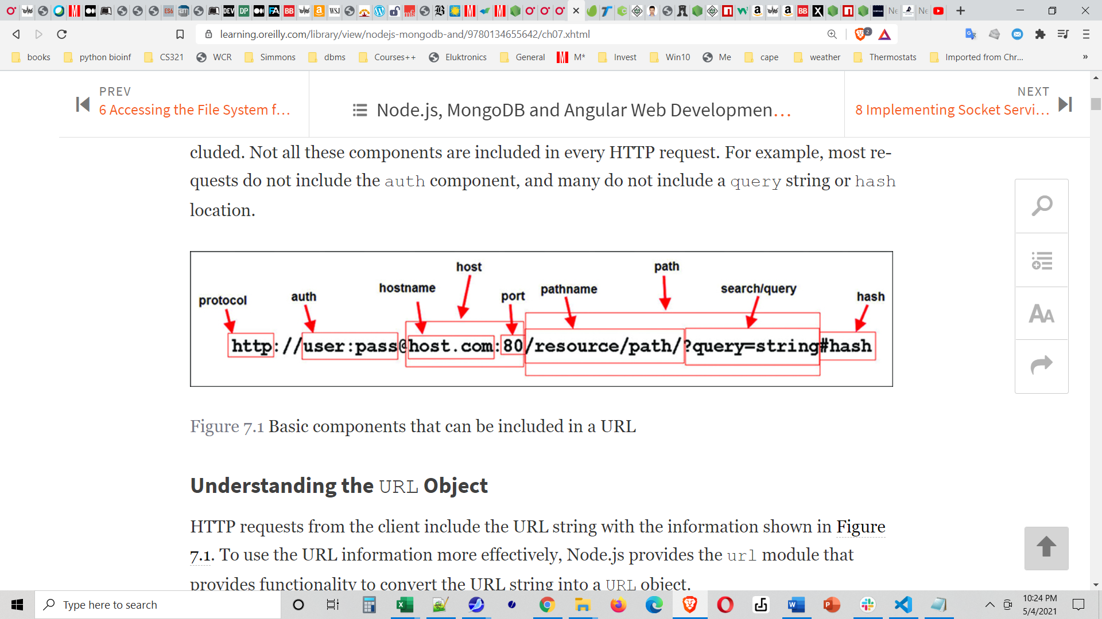
And we can extract all of these usin the path module, which has a parse method.
https://nodejs.org/api/path.html#path_path_parse_path

As time allows – brief look at Chapter 7 of the Dayley book.
Note that url.parse() has been replaced by URLSearchParams -see https://nodejs.org/docs/latest/api/url.html#url_class_urlsearchparams or the origin proprty on req.url --- see diagram at https://nodejs.org/docs/latest/api/path.html#path_path_parse_path
As pointed out at Node.js URLsearchParams API - GeeksforGeeks we can access the .get method of a URLSearchParams object to get a specific value.
But we will take the easier way, and use Express.
Express is a small and flexible framework, which likes to describe itself as unopinionated.
There are several good reasons to do this --- it saves us a lot of low-level coding, and also it makes the management of large websites much, much easier.
The most popular framework for doing this is Express – and Chapter 18 of the Brad Dayley book has a very clear introduction to it. https://learning.oreilly.com/library/view/nodejs-mongodb-and/9780134655642/ch18.xhtml#ch18 There is also a Brad Traversy video at https://www.youtube.com/watch?v=L72fhGm1tfE (Postman is a Chrome extension which will simply make a get or post request) and a tutorial at ExpressJS Tutorial - Tutorialspoint -start at the ExpressJS - Hello World - Tutorialspoint Hello World page.
There is an excllent tutorial at Express/Node introduction - Learn web development | MDN (mozilla.org) and you know that that one (unlike many others) will be current.
Okay – let's use Express!!! Here are the steps:
install in the folder for your project
It's easier if you do it before the npm init, but if you have already created the package.json file, then install express with the –save option.
Or install express globally (I'll assume you did that)

The basic format is
express = require('express');
app = express();
app.listen(3000);

and then you handle requests with:
for a get request from a route /someRoute
app. get(/someRoute, (req, res) => {whateverCode} );

for a post request from a route /someRoute
app. post(/someRoute, (req, res) => {whateverCode} );
NOTE: The callback functions (req, res) => {whateverCode} should have as their last line next(); which is needed to pass control to the next handler.
In express, instead of writing headers etc we use
res.send(stuff);

In order to handle (parse) data in the body of a POST request or from the URL-encoded GET request, we first bring in some extra help. (Here are are using the express version of what we previously did by parsing the req.url or the body in vanilla Node.)

app.use(express.urlencoded()); //Handle urlencoded data such as from a GET
app.use(express.json()); //Handle json data such as in the body of a POST
//request.body/someKey will have the associated valueb

Some people prefer to require the body-parser module:
In older code you will see the bodyParser required as a separate module, as in:

var bodyParser = require('body-parser');

//To parse URL encoded data
app.use(bodyParser.urlencoded({ extended: false }))

//To parse json data
app.use(bodyParser.json())

But the body-parser is now part or Express and you should NOT require it separately.
So, now we code:
app.use(express.urlencoded({extended: true}));
app.use(express.json()) // To parse the incoming requests with JSON payloads

Other examples are discussed at https://stackoverflow.com/questions/66525078/bodyparser-is-deprecated
Note: When you are writing a server-side script to handle a post, you know the names of the form elements you were sent. So, if you are not using Node, you can use
myURL = whatever you got from the request object;
let aValue = myURL.searchParams. get('nameOfElement');
If the element on the form may have multiple values:
let arrayOfValues = myURL.searchParams. getAll('nameOfElement');
See https://nodejs.org/api/url.html#the-whatwg-url-api for the documentation on the URL module, and the WHATWG documentation or see https://www.geeksforgeeks.org/node-js-urlsearchparams-api/ for examples.
Please also note that the URL module is used to construct new URLs. And https://nodejs.org/api/url.html#url-strings-and-url-objects has a very clear picture showing the parts/methods of a URL with the legacy (deprecated) names above the URL and the new WHATWG parts/methods below. The username and password in the legacy version had security issues, which is why that API has been deprecated.
What next?
- For express we might want to learn more about how to handle many routes
- We might want to learn how to use the data from a request and interact with a mongodb database (there are node modules mongo and mongoose)
- We might want to learn about a template engine (e. g. pug or handlebars or ejs
- We might want to learn about a framework like Angular for the front end. Angular appears to be declining in popularity --- REACT has been gaining.

