Brad Dayley – Chapter 18 and 19 on Express
https://learning.oreilly.com/library/view/node-js-mongodb-and/9780133844351/ch18lev2sec1.html#ch18lev2sec1

Express settings:

Configuring Express Settings
Express provides several application settings that control the behavior of the Express server. These settings define the environment as well as how Express handles JSON parsing, routing, and views. Table 18.1 lists the settings that can be defined on an express object.
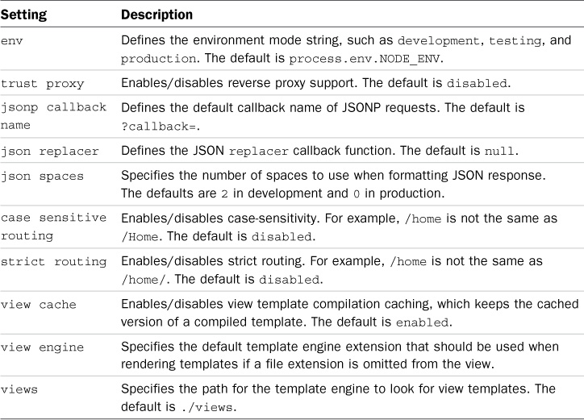

You might ask: How are starting servers in Express related to those started with the http (core) module?
Dayley informs us:
var express = require('express');
var app = express();
app.listen(8080);
The app.listen(port) call binds the underlying HTTP connection to the port and begins listening on it. The underlying HTTP connection is the same connection produced using the listen() method on a Server object created using the http library discussed in Chapter 7 “Implementing HTTP Services in Node.js.”
In fact, the value returned by express() is actually a callback function that maps to the callback function that is passed to the http.createServer() and https.createServer() methods.

Dayley uses the following to create http and https servers:
var express = require('express');
02 var https = require('https');
03 var http = require('http');
04 var fs = require('fs');
05 var app = express();
06 var options = {
07 host: '127.0.0.1',
08 key: fs.readFileSync('ssl/server.key'),
09 cert: fs.readFileSync('ssl/server.crt')
10 };
11 http.createServer(app).listen(80);
12 https.createServer(options, app).listen(443);
13 app.get('/', function(req, res){
14 res.send('Hello from Express');
15 });

When we want to use routes (endpoints) the syntax is:
app.get(path, [middleware, ...], callback)
app.post(path, [middleware, ...], callback)

The Request Object:
28h 45m remaining

Using Request Objects
You pass a Request object to a route handler as the first parameter. The Request object provides data and metadata about the request, including the URL, headers, query string, and much more. It allows you to handle a request appropriately in your code.
Table 18.2 lists some of the most commonly used properties and methods available for the Request object.
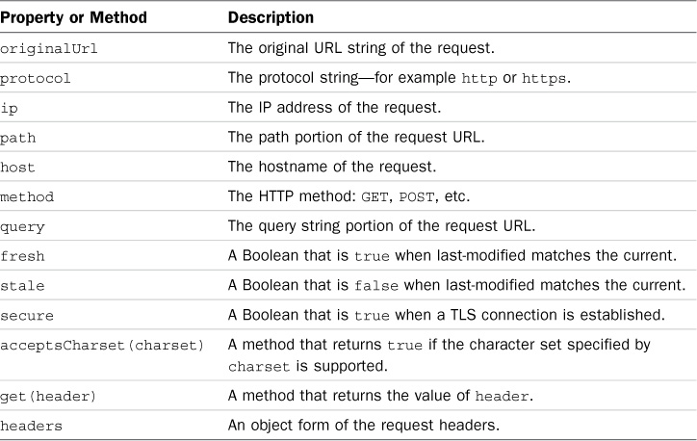
Table 18.2 Properties and methods of the HTTP Request object

The Response Object:
28h 45m remaining

Setting Headers
An important part of formulating a proper HTTP response is to set the headers. For example, setting the Content-Type header tells the browser how to handle responses. The Response object provides several helper methods to get and set the header values that are sent with HTTP responses.
The most commonly used methods are get(header) and set(header, value), which get and set any header value. For example, the following code first gets the Content-Type header and then sets it:
Click here to view code image
var oldType = res.get('Content-Type');
res.set('Content-Type', 'text/plain');
Table 18.3 describes the helper methods to get and set header values.
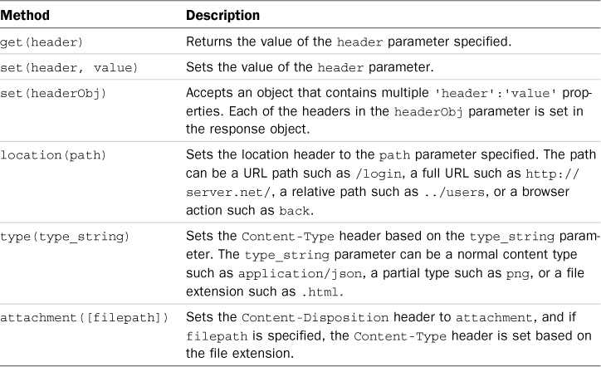
Table 18.3 Methods to get and set header values on the Response object

Settin status codes:
res.status(200); // OK
res.status(300); // Redirection
res.status(400); // Bad Request
res.status(401); // Unauthorized
res.status(403); // Forbidden
res.status(500); // Server Error

