Working on Anita
- Double click on PutTy (or other telnet/SSH client).
- Enter anita.simmons.edu for the Host Name
The Port should be set to 22.
The SSH Connection Type should be selected.
- 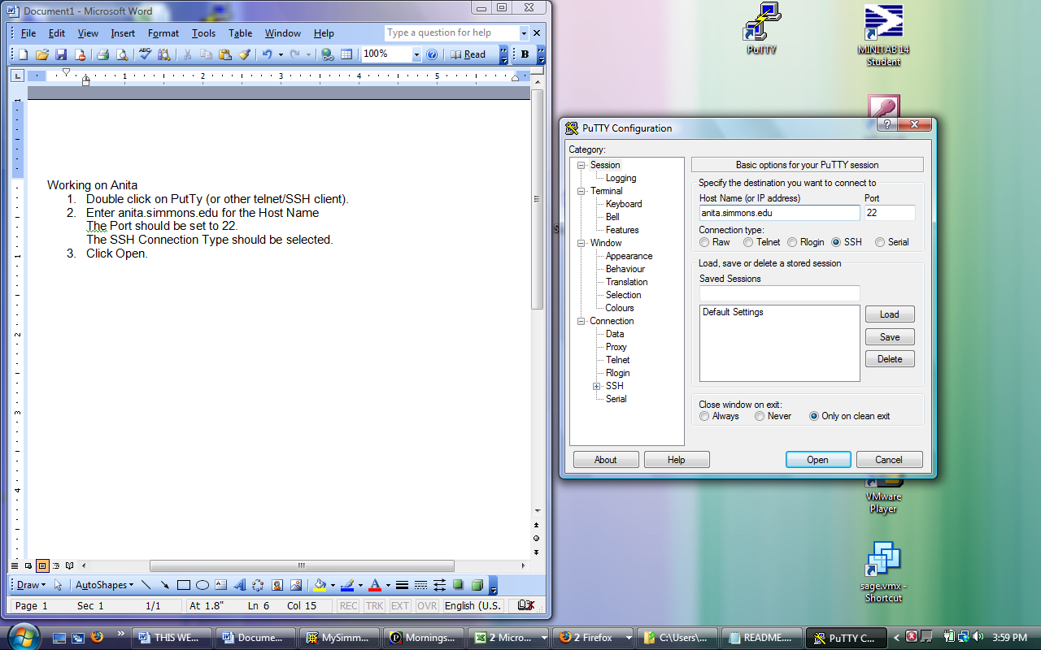
- Click Open.
- A black window will open up with the phrase login as:
- Type in your user name.
- Anita responds with: your_user_name@anita.simmons.edu’s password:
- Enter your password (there are no symbols displayed) and Enter.
- Anita responds with the time of your last login and something like:
[your_user_name@anita ~] $
- The $ is Anita’s prompt.
- Type pwd (for print working directory) and Enter
- Anita responds /home/your_user_name
- Type ls (Enter).
- Anita responds with a list of the folders and files in your directory (probably none at this point).
- Type mkdir public_html (mkdir stands for make directory)
- Type ls –l
- Anita responds with a list of the directories and the permission as to who may use them.
- Type chmod public_html 755
- Again type ls –l
- Type cd public_html (cd is change directory) and then pwd
- Type cd .. and pwd
- Type exit.

Anita is a “Linux box”, which means that its operating system is Linux, the pc-version of UNIX. UNIX has a long and glorious history, Linux a shorter and glorious one. Both are available open source and there is a lot of documentation and tutorials for both available on line.

Here is a list of several short and easy references:

http://infohost.nmt.edu/tcc/help/unix/unix_cmd.html
This is a tutorial from New Mexico Tech. It has been around (presumably refined) for a long time and it tells you how to do things in a table organized from the point of view of what you want to do.

http://freeengineer.org/learnUNIXin10minutes.html
Another good, short introduction to everything you need to know in UNIX(Linux)

http://www.bridgewater.edu/cescc/acadcomp/UnixPrimer.htm
Another short tutorial from U. Mass Bridgewater.

http://babbage.clarku.edu/~achou/UnixPrimer/
The UNIX primer from Clark University; this one goes a little further than the others

http://www.cyberciti.biz/nixcraft/linux/docs/uniqlinuxfeatures/lsst/ch01.html
This one is an on-line book, and it has a lot more information, including an introduction to shell scripts (which you will write) at http://www.cyberciti.biz/nixcraft/linux/docs/uniqlinuxfeatures/lsst/ch01sec09.html and http://www.cyberciti.biz/nixcraft/linux/docs/uniqlinuxfeatures/lsst/ch02.html

Right now you need to know the following commands:
ls and ls –l List and List in Long format
lpr Print (actually Line Printer)
pwd Print Working Directory
cd Change directory name-where-you-are-going
.. goes up one level
/ is the separator
There are no blank spaces allowed in file names
cp file1 file2 Makes a copy of file1 and stores it under file2
mv file1 file2 Moves file1 to file2 (and erases file1)
cat filename Concatenate (to the output) the contents of the file
– displays it on the screen
rm filename Removes (ERASES) the file.
chmod filename number Changes the permissions on the file – easier to set via
CoreFTP Lite.
man command Displays the manual’s section on that command
vim or vi A very old fashioned text editor – more on this later.
exit Log-off

