Using XMLSpy – the views and entering data

1. We open XMLSpy and click on File -> New ->xsd file
2. We are presented with
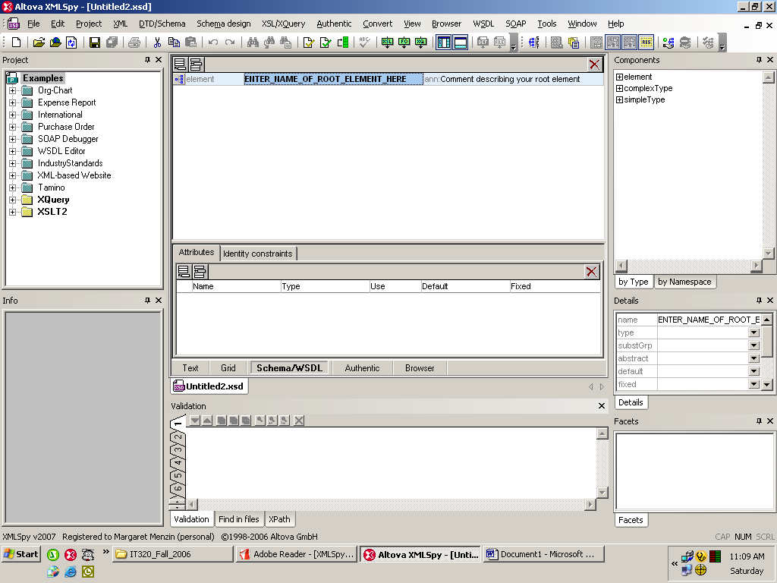

This is in Schema/WSDL view.

3. In a flight of creativity, I will name the root element Top_Level, and enter a comment.
Now let’s see how this looks in different views:
In Text View it looks like:

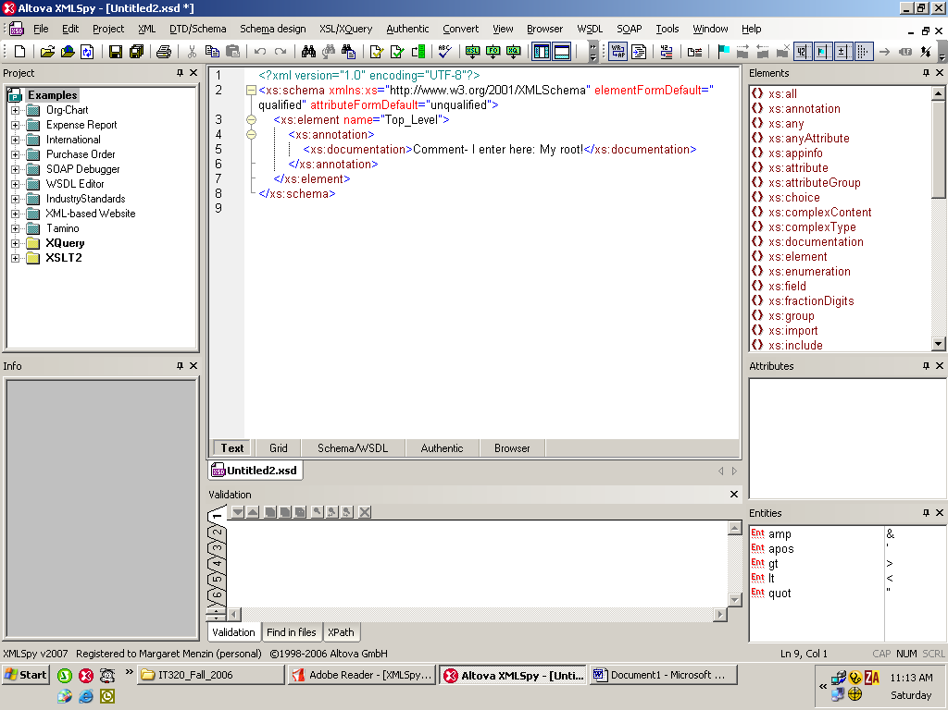

Notice all the elements from the xs namespace on the right!

In browser view it looks like:
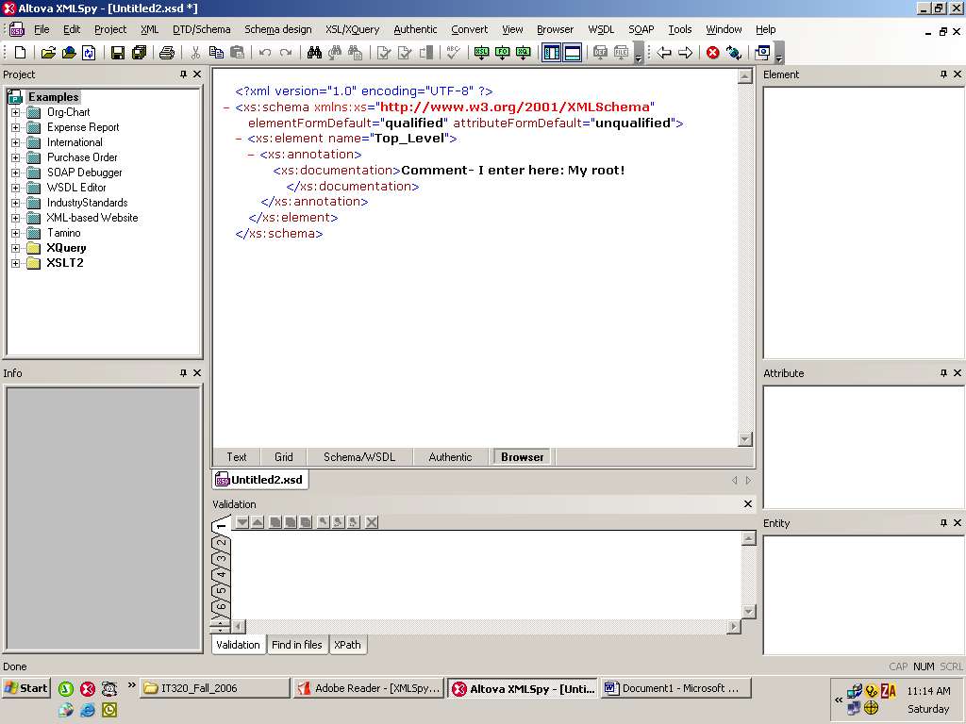

Notice that the tree shows (as in I.E. or Firefox), but the design information on the right is gone.

In grid view it looks like:
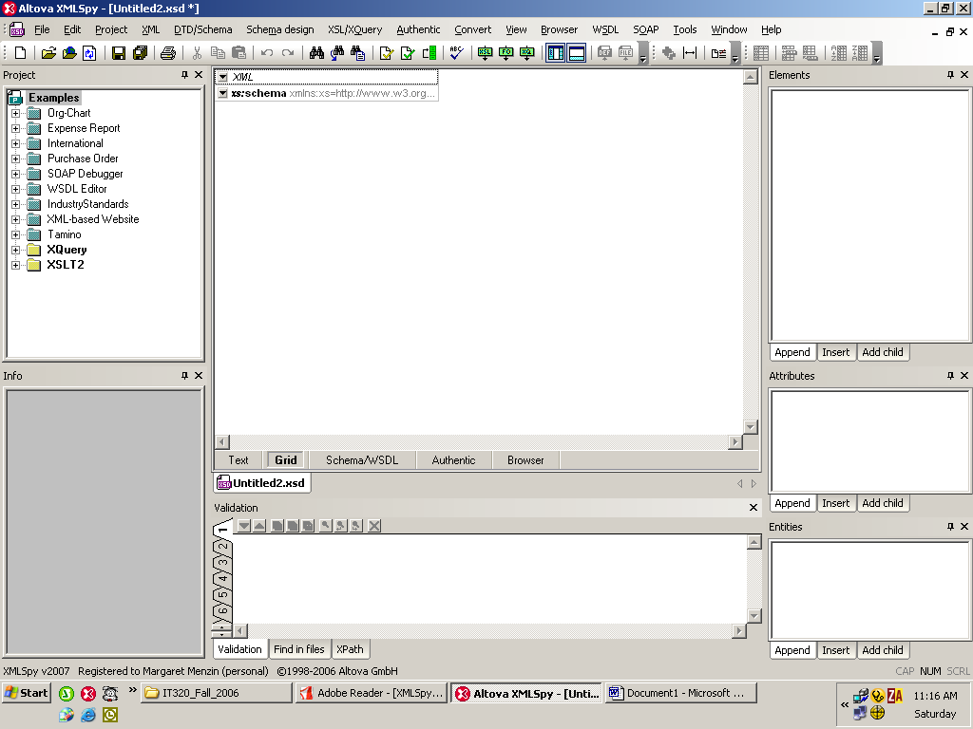

Now we go back to Schema view and click on the tree icon just to the left of the word Element and we get:
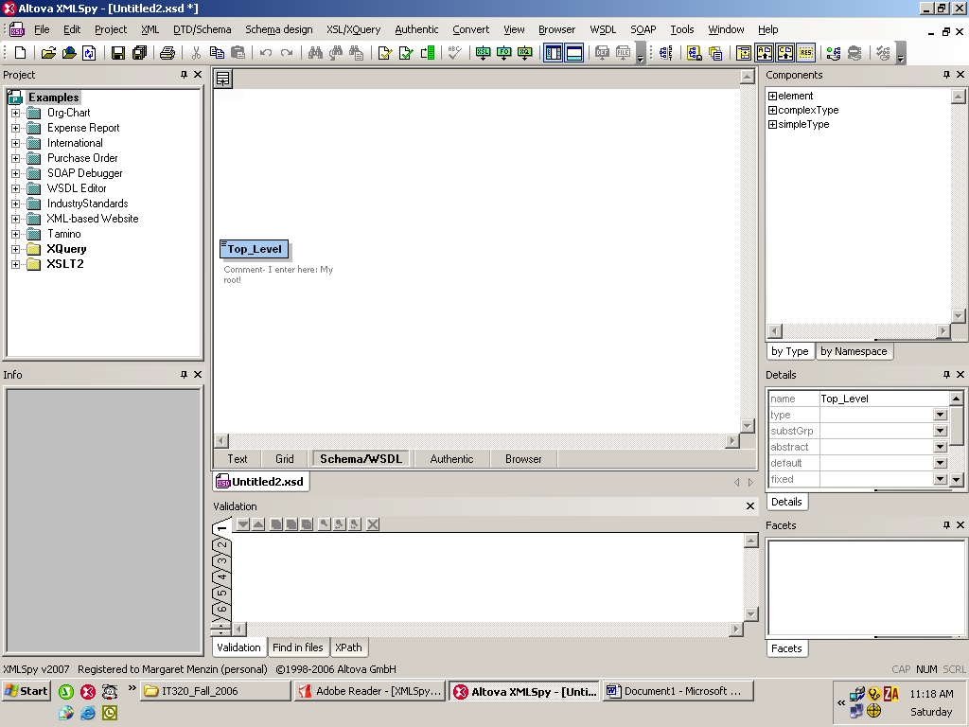

(Clicking on the list at the upper left of the middle top pane gets us back to the previous view, but we won’t do that yet.)

I am now going to make Top_Level have a sequence of Level2 children. (In the other view we can also do this, using the Details pane on the right side., but it’s easier in the graphical view.)

Right click on Top_Level. Following the Add Child option, we may add a sequence, or a choice, or all of children. Choose sequence.

Right click on the oval with the 3 dots and choose Add Child ->Element and name that child Level2a. Repeat to give Top_Level another child named Level2b.

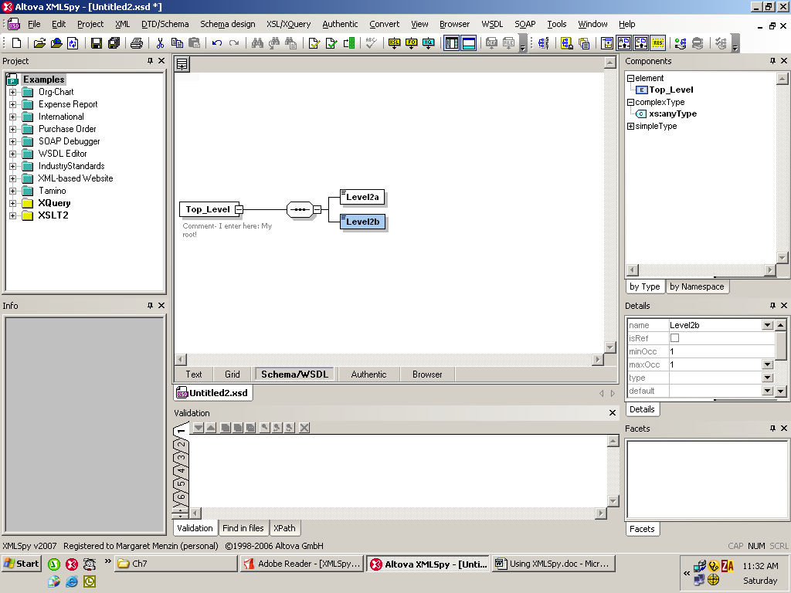

Check out the Text View, and then come back here.

Click on Level2a and then go to the Details pane and set minOccurs to be 0 and maxOccurs to be 1. For Level2b set the minOccurs to be 1 and the maxOccurs to be unbounded.

Your diagram should now have the box around Level2a dotted (indicating that it is optional, as minOccurs is 0) and below Level2b should be a 1…∞

Go back to Level2a and in the Details pane set its type to be xs:date.

Go back to Level2b and in the Details pane check off isRef.

Your page should look like:
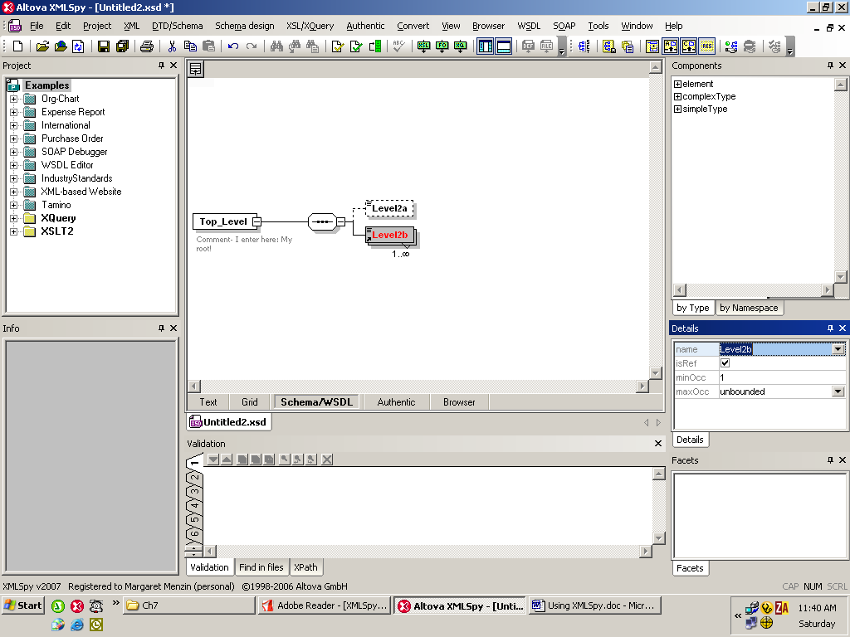

Now check out the Text View.

Going back to the Text View, I added some more definitions.
The text view looks like:

<?xml version="1.0" encoding="UTF-8"?>
<xs:schema xmlns:xs="http://www.w3.org/2001/XMLSchema" elementFormDefault="qualified" attributeFormDefault="unqualified">
<xs:element name="Top_Level">
<xs:annotation>
<xs:documentation>Comment- I enter here: My root!
</xs:documentation>
</xs:annotation>
<xs:complexType>
<xs:sequence>
<xs:element name="Level2a" type="xs:date"
minOccurs="0"/>
<xs:element ref="Level2b" maxOccurs="unbounded"/>
</xs:sequence>
</xs:complexType>
</xs:element>
<xs:element name="Level2b">
<xs:complexType>
<xs:sequence>
<xs:element name="Level2b1" type="xs:string"/>
<xs:element name="Level2b2" type="xs:integer"/>
<xs:element ref="Level2b3" maxOccurs="6"/>
</xs:sequence>
</xs:complexType>
</xs:element>
<xs:element name="Level2b3" type="Level2b3Type"/>
<xs:complexType name="Level2b3Type"/>
</xs:schema>

The Broswer View looks like:
<?xml version="1.0" encoding="UTF-8" ?>
- <xs:schema xmlns:xs="http://www.w3.org/2001/XMLSchema" elementFormDefault="qualified" attributeFormDefault="unqualified">
- <xs:element name="Top_Level">
- <xs:annotation>
<xs:documentation>Comment- I enter here: My root!</xs:documentation>
</xs:annotation>
- <xs:complexType>
- <xs:sequence>
<xs:element name="Level2a" type="xs:date" minOccurs="0" />
<xs:element ref="Level2b" maxOccurs="unbounded" />
</xs:sequence>
</xs:complexType>
</xs:element>
- <xs:element name="Level2b">
- <xs:complexType>
- <xs:sequence>
<xs:element name="Level2b1" type="xs:string" />
<xs:element name="Level2b2" type="xs:integer" />
<xs:element ref="Level2b3" maxOccurs="6" />
</xs:sequence>
</xs:complexType>
</xs:element>
<xs:element name="Level2b3" type="Level2b3Type" />
<xs:complexType name="Level2b3Type" />
</xs:schema>

The (expanded) Grid View looks like:
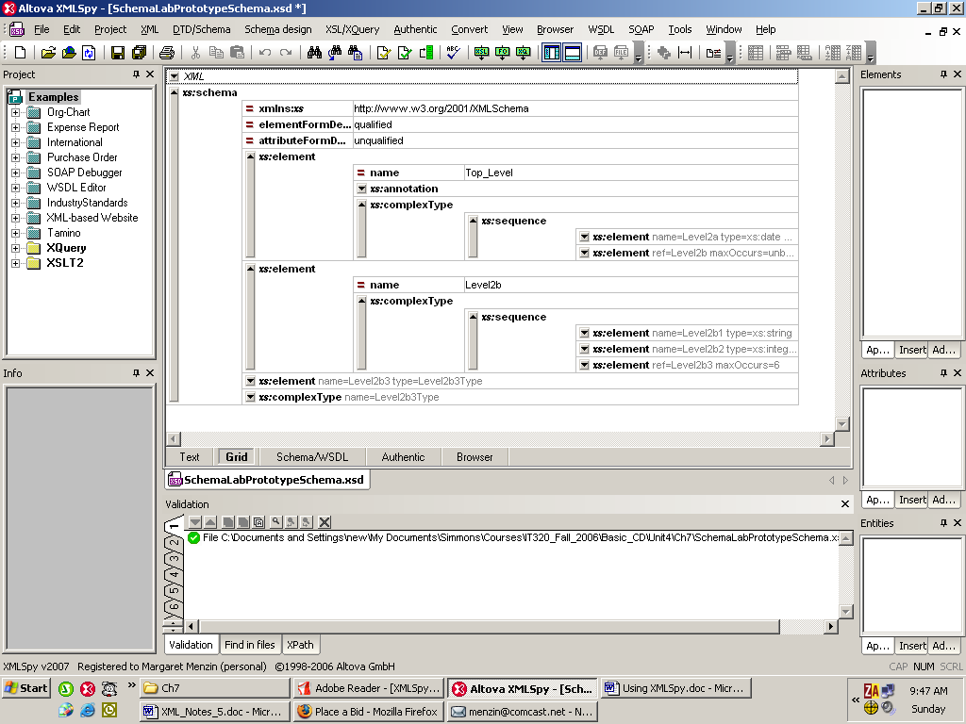

The Schema View looks like:
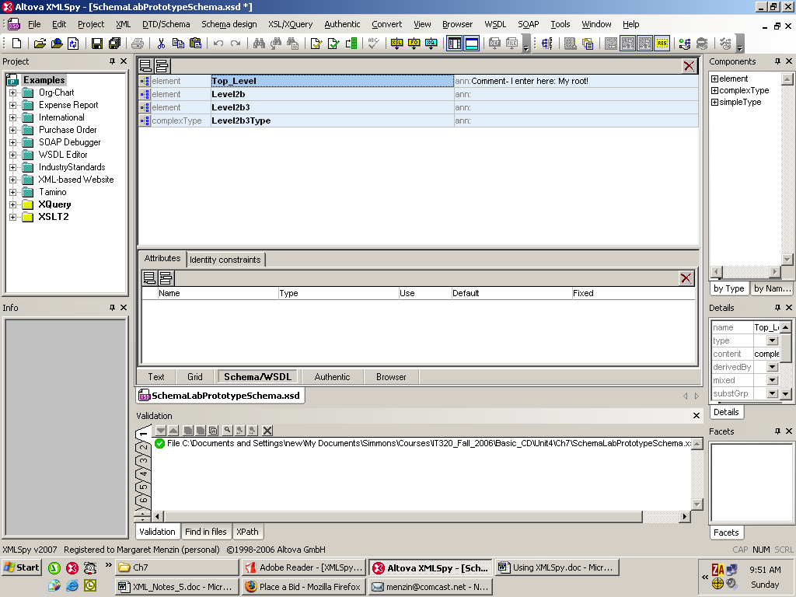

Notice that all the global definitions are shown.

Expanding on the Top_Level tree we get:
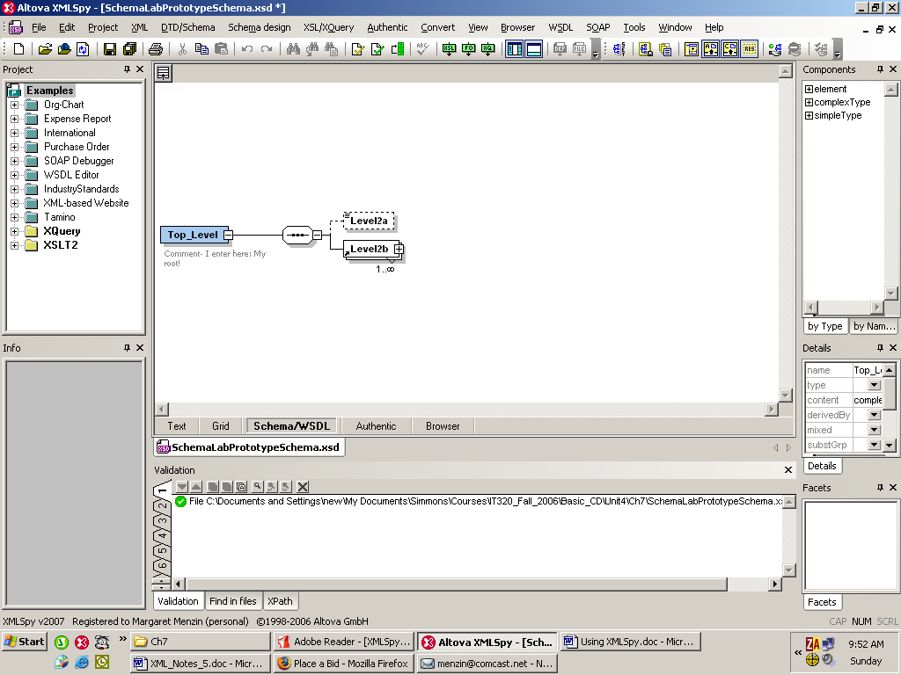

and we need to look at the Level2b tree to see its definition.

We are now going to add to the (currently empty) definition of Level2b3Type. We will put in a sequence of 2 elements – one (Level2b3a) will be a choice and the other (Level2b3b) a restriction of integers.

My final schema looks like:
<?xml version="1.0" encoding="UTF-8"?>
<xs:schema xmlns:xs="http://www.w3.org/2001/XMLSchema" elementFormDefault="qualified" attributeFormDefault="unqualified">
<xs:element name="Top_Level">
<xs:annotation>
<xs:documentation>Comment- I enter here: My root!</xs:documentation>
</xs:annotation>
<xs:complexType>
<xs:sequence>
<xs:element name="Level2a" type="xs:date" minOccurs="0"/>
<xs:element ref="Level2b" maxOccurs="unbounded"/>
</xs:sequence>
</xs:complexType>
</xs:element>
<xs:element name="Level2b">
<xs:complexType>
<xs:sequence>
<xs:element name="Level2b1" type="xs:string"/>
<xs:element name="Level2b2" type="xs:integer"/>
<xs:element ref="Level2b3" maxOccurs="6"/>
</xs:sequence>
</xs:complexType>
</xs:element>
<xs:element name="Level2b3" type="Level2b3Type"/>

<xs:complexType name="Level2b3Type">
<xs:sequence>
<xs:element name="Level2b3a" type="MajorType"/>
<xs:element name="Level2b3b" type="CreditType"/>
</xs:sequence>
</xs:complexType>

<xs:simpleType name="MajorType" >
<xs:restriction base="xs:string">
<xs:enumeration value="CS"/>
<xs:enumeration value="IT"/>
<xs:enumeration value="Math"/>
</xs:restriction>
</xs:simpleType>

<xs:simpleType name="CreditType">
<xs:restriction base="xs:integer">
<xs:minInclusive value="1"/>
<xs:maxInclusive value="6"/>
</xs:restriction>
</xs:simpleType>

</xs:schema>

Please notice:
- xs: restriction, xs:minInclusive, etc.
- An enumeration list is an xs:simpleType (NOT a complex type)
- In an enumeration list eah value is listed separately (empty form)
- Likewise a restriction to certain numerical values is a simple type.

In the final grid view, please look at the Components pane on the right.
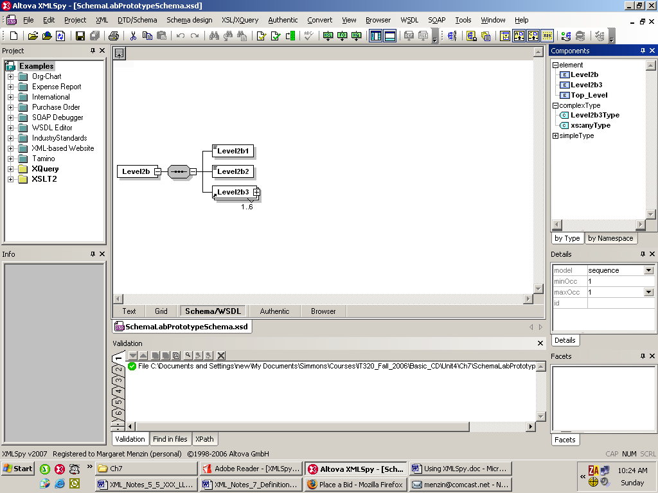

Finally, here is the completely expanded Grid View (in 2 pieces):


