Please read the following paragraph quietly to yourself.

Call me Ishmael. Some years ago -- never mind how long precisely -- having little or no money in my purse, and nothing particular to interest me on shore, I thought I would sail about a little and see the watery part of the world. It is a way I have of driving off the spleen and regulating the circulation. Whenever I find myself growing grim about the mouth; whenever it is a damp, drizzly November in my soul; whenever I find myself involuntarily pausing before coffin warehouses, and bringing up the rear of every funeral I meet; and especially whenever my hypos get such an upper hand of me, that it requires a strong moral principle to prevent me from deliberately stepping into the street, and methodically knocking people's hats off -- then, I account it high time to get to sea as soon as I can. This is my substitute for pistol and ball. With a philosophical flourish Cato throws himself upon his sword; I quietly take to the ship. There is nothing surprising in this. If they but knew it, almost all men in their degree, some time or other, cherish very nearly the same feelings towards the ocean with me.

When you are finished, please let the experimenter know.
#3 Which of the six shapes (A-F) is identical to the first one? There may be more than one which is exactly the same.
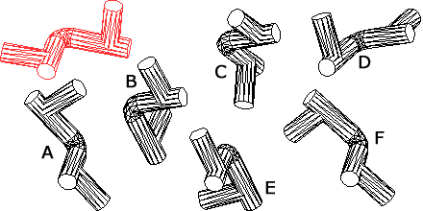

#4 Below, 10 nine letter words have been broken into chunks of three letters. These chunks have been mixed up, no chunk is used twice and all chunks are used. Can you determine what the 10 words are?
tin som mea and all ple
sca eth ile rbr man ssl
pol rec hai yes gra wat
ing ter ice eap erf ate
nwh pin obs ush row day

#5 Below is a very special grid. Around each shaded number are 8 white squares. Each white square should have a number from 1 to 7. Once filled in, these 8 numbers will sum to the shaded number. In addition, once completed correctly, no row or column will contain any duplicate numbers in white squares.
